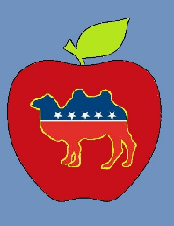
Think NY Vote Dry

The New York Prohibition Party is the new state party organization of the Prohibition Party in New York. We are an organization that believes in good governance and promoting policies that benefit the wellbeing and success of people in New York State.
We believe that government should serve the people, and that it should use its legitimate powers to promote the public welfare, establish justice, and allow people to pursue improvement.
We encourage our elected officials to fulfill their responsibilities as public servants, and believe in calling them to account when they don’t. We are opposed to government corruption, and support stronger laws to combat it.
We recognize that alcohol and other intoxicating drugs are a poison to the minds and bodies of people, and that they bring vast personal, social, medical, and economic damages to our society. As such we support policies to restrict and prohibit these substances, programs to encourage abstinence from these substances, and programs to provide treatment for those addicted.
We support policies to improve the quality of public education, and to help people be able to pursue the college or vocational education suited for them.
We support projects to help bring prosperity to our communities.
We support protecting the environment in a balanced manner that takes into account economic needs.
We support reforming our state’s fiscal system to reduce the burdens placed on local governments, and by consequence help lower property taxes.
We support fixing and revitalizing the state’s infrastructure.

If you would like to find out more about us, you may check out our website: https://newyorkprohibition.wixsite.com/new-york-prohibition
or email us at newyorkprohibition@aol.com

